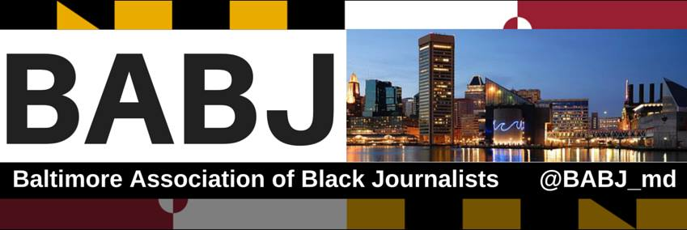
Mentor Program Application
Application Period: September 26, 2016 – October 24, 2016

Contact Information
Full Name:
Street Address:
City, State ZIP Code:
Home Phone:
Cell Phone:
E-Mail:

Current Education Status

Current Cumulative GPA (3.0 GPA minimum required): _________________
Major/Concentration: __________________________________________

Sophomore
Junior
Senior
Graduate Student

Social Media

Please provide your social media handles for the following platforms:
Twitter: _______ I do not have a Twitter account.
LinkedIn: _______ I do not have a LinkedIn account.

Essay Questions: Please limit each answer to 350 words or less). You may opt to type your answers as a separate document.
What are your plans for your major in Journalism, Communications or Public Relations?

Where do you see yourself in 10 years?

Agreement and Signature

By submitting this application, I affirm that the facts set forth in it are true and complete. I understand that if I am accepted into the BABJ Mentor Program, any false statements, omissions, or other misrepresentations made by me on this application may result in my immediate dismissal.
Name (your typed name serves as your signature):
Date:

Application Submission and Guidelines

Thank you for your interest in the Baltimore Association of Black Journalists Mentor Program.
You must submit the following:
- Completed Application
- Unofficial Transcript (NOTE: If called for an interview you will be required to bring/send an official, sealed transcript)
- Three (3) writing samples
- Photo (JPEG format preferred)*

*NOTE: If selected for the program, your photo may be used by BABJ for marketing purposes.

Submission Method: Electronic Only

Please scan your completed application and supporting materials and email them as PDF documents to BABJ’s official email at babjmd@gmail.com. All submissions must be emailed by 11:59 p.m. EST on October 24, 2016.

Incomplete and/or falsified applications, as well as plagiarized writing samples are grounds for disqualification and will not be processed.
Eligible students will be notified for an interview if they qualify. We will notify selected students of their acceptance to the program on Friday, October 28, 2016. The new session will launch on Tuesday, November 1, 2016.

